Report by Joynal Abedin

# Documentation

**NETCAT**

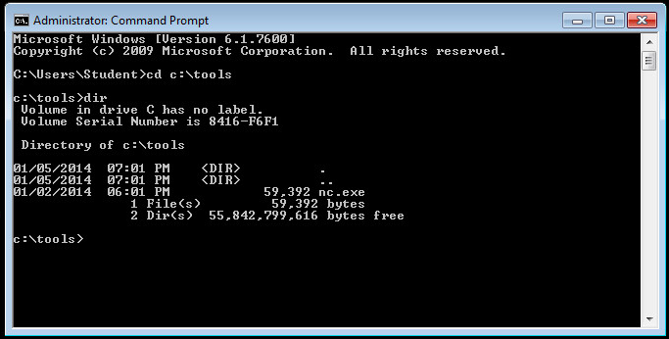

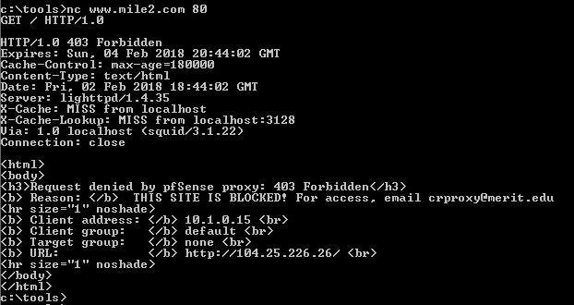

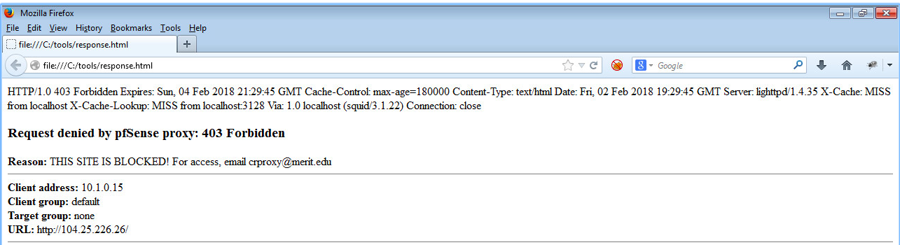

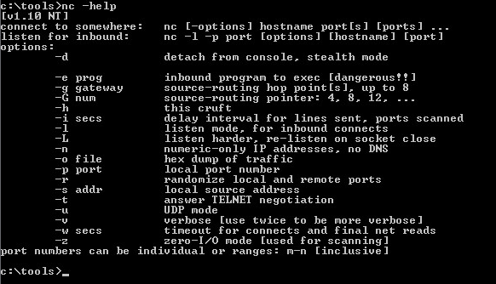

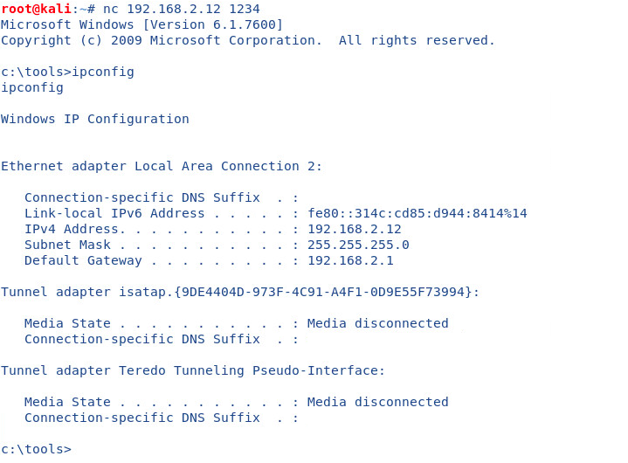

**Capture FTP Traffic**

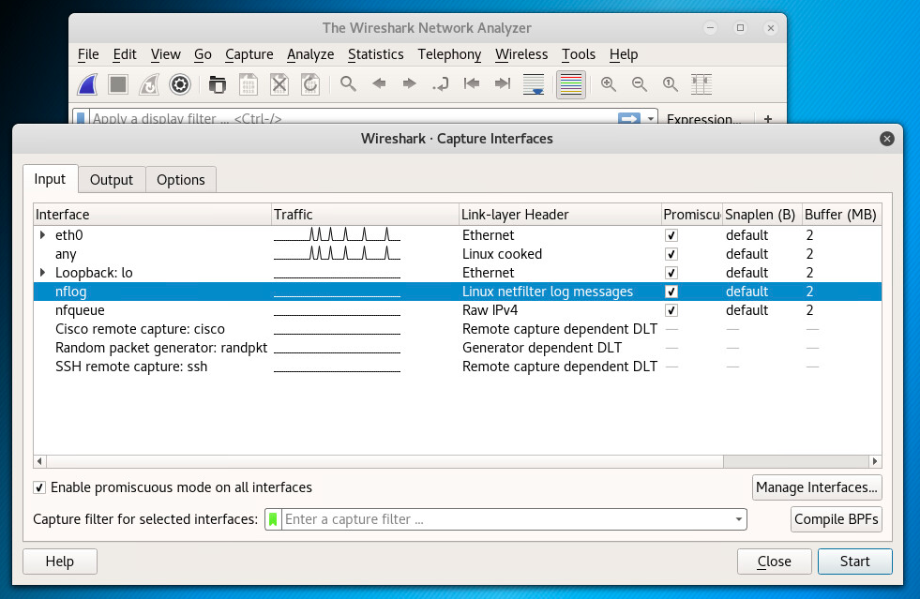

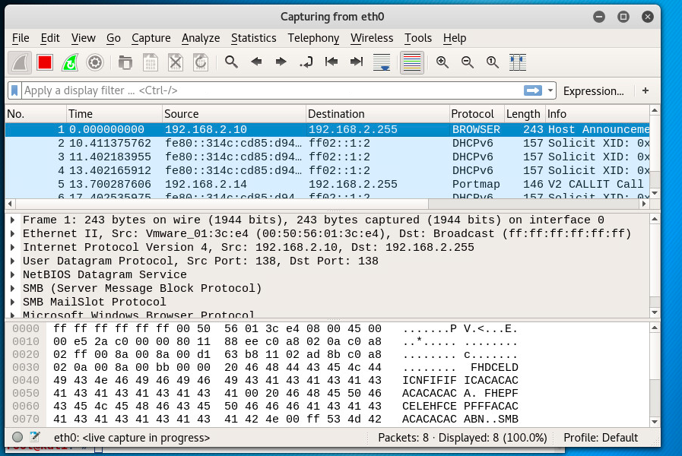

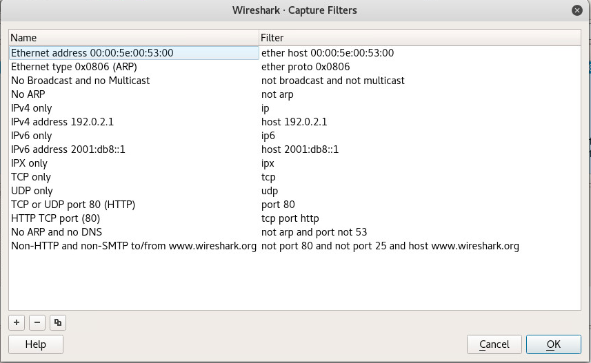

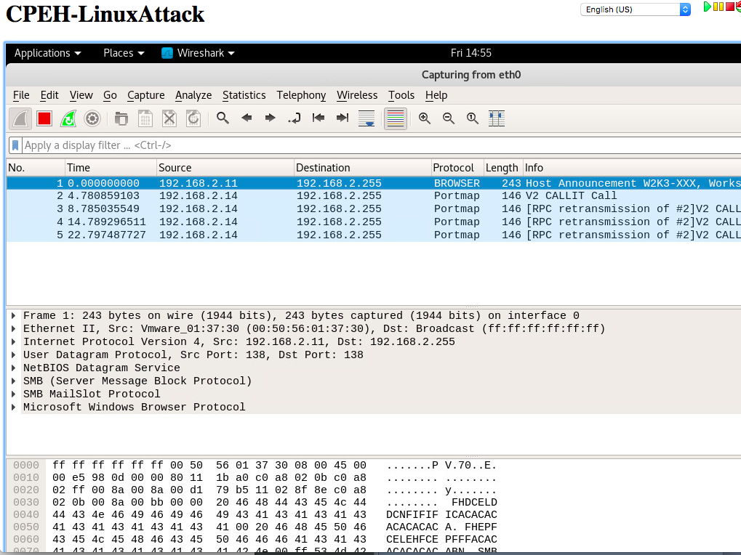

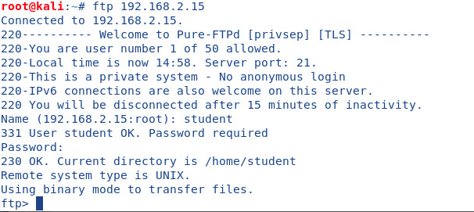

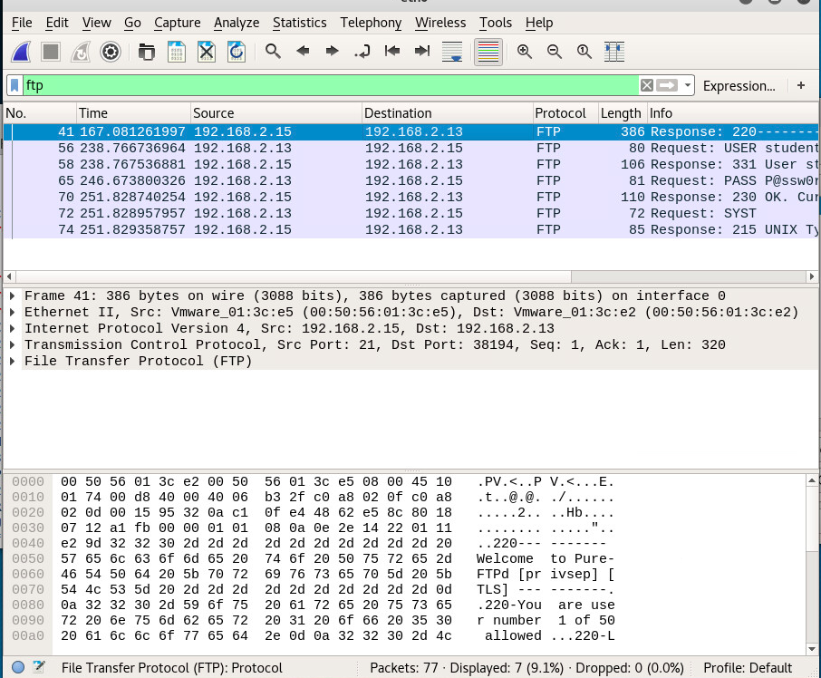

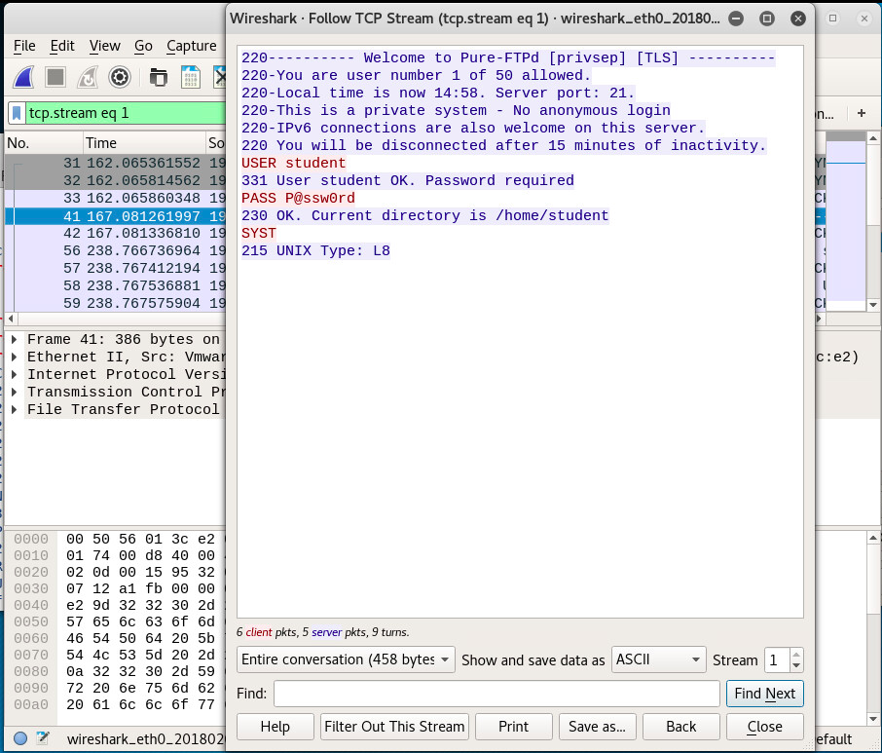

# Vulnerabilities

## Vulnerability 01

### Description

The FTP is a TCP/IP protocol that allows files transfers between FTP servers and clients. FTP has a drawback while doing authentication, the data will transfer in plain text, which can be read by anyone who’s sniffing into the traffic to capture a few username or password for bad intention.

### Relative Risk (High, Medium, Low)

* Medium
  + Approximately 10 times more expensive than a “low” risk
  + additional budget request may be required

### Mitigation

One way to mitigate this kind of vulnerability is to choose SFTP (secure) and enable Anti-hacking feature on a FTP server. Also, limit the number of password attempts one can make before locked out.

While FTP is sometimes a requirement because it’s easy and cost-effective for file transferring, however, it is always best to check your security protocol regularly to stay up to date.